Got to Meet Setup 🡪 Meet Style 🡪 3+ Team

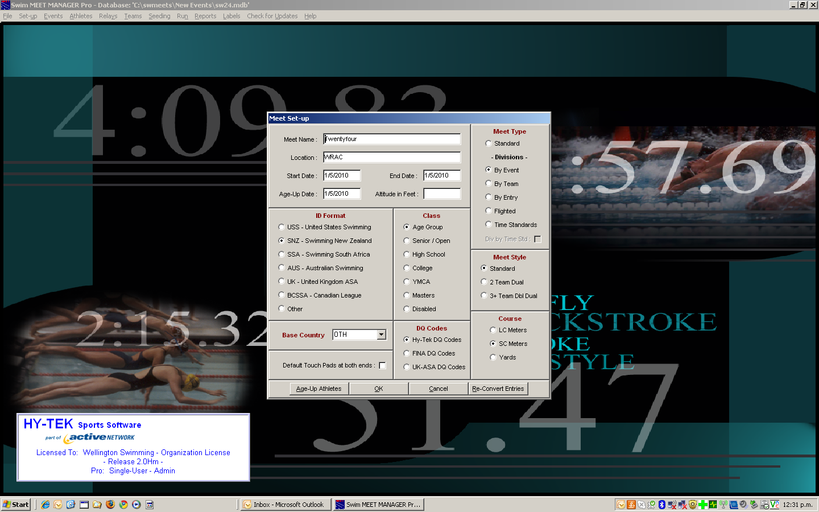

Go to Seeding Preference 🡪 Dual Meet

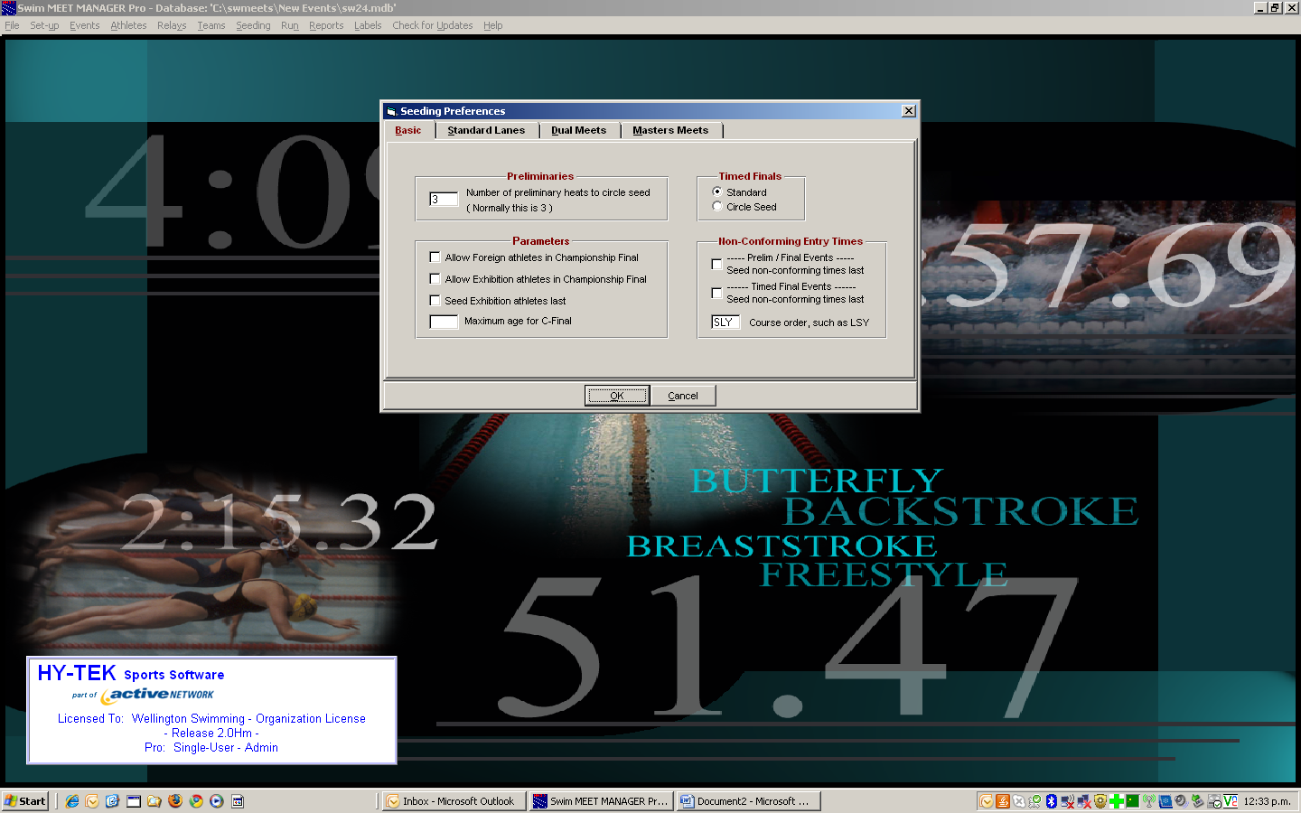

Set up lanes

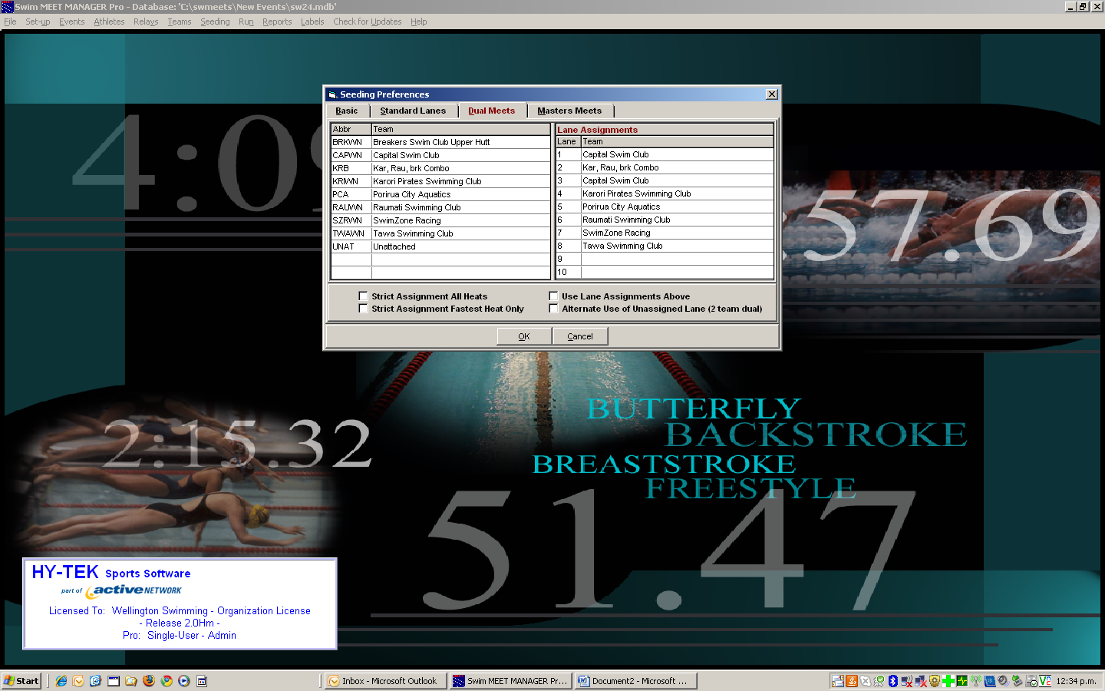

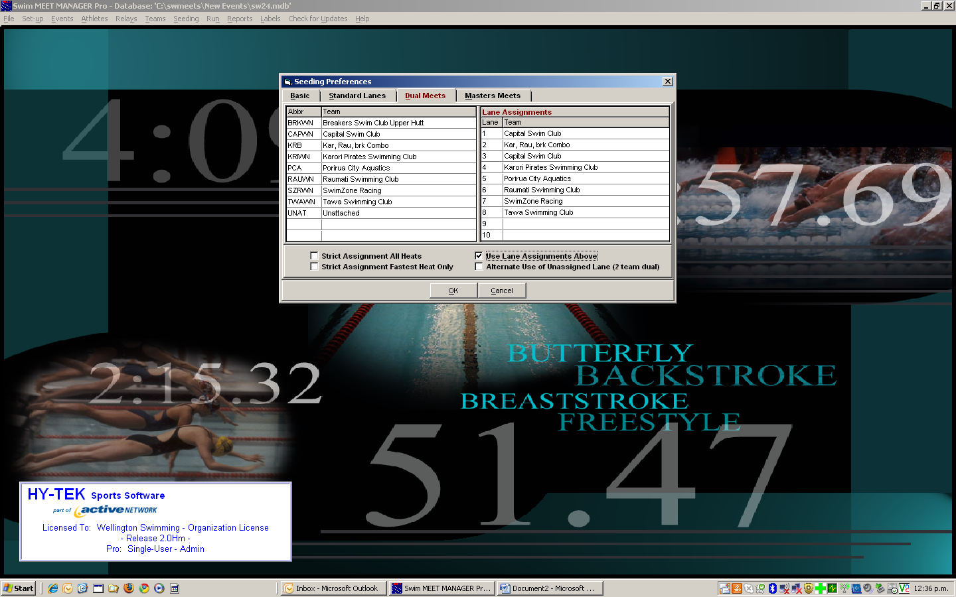

Tick ‘Use Lane Assignment Above’